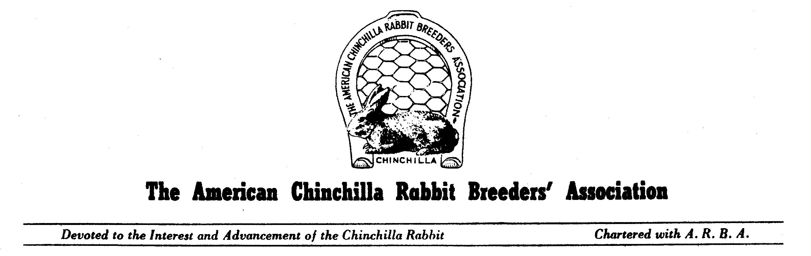
ACRBA Membership Application Form

New Member ______ Member Renewal______ Membership Application Year ______

Adult 1yr - $9.00 3yr - $20.00 Youth 1yr - $6.00 3yr - $12.00 Lifetime Membership $100.00

Husband/Wife 1yr - $13.00 3yr - $30.00 Family Membership 1yr - $13.00 plus $2.00 per youth

3yr - $30.00 plus $6.00 per youth Foreign Membership – add $5.00

Name: _________________________________ Birthday: (Youth Only) _______________________

_________________________________ E-Mail: ___________________________________

_________________________________ Phone: ___________________________________

Address: _____________________________________________ ARBA# ________________________

_____________________________________________

City: _________________________ State: ________________________ Zip: ___________________

Total Paid: __________Cash_______Check #:_________PayPal__________Date Paid: _____________

You can now pay your membership dues by PayPal. Send funds to: nationalacrba@gmail.com
Please note in the comment section that this is for dues. Then mail or email your completed application form to the address below.

Send To:
ACRBA Secretary
Ramona Richardson
6595 E. Robinson Road
Bloomington, IN 47408
812-339-2333
richardsonsfeed@sbcglobal.net

